**TRAVELGO : A CLOUD-POWERED REAL -TIME**

**TRAVEL BOOKING PLATFORM**

**Project Description:**

**TravelGo** is a **cloud-based real-time travel booking platform** designed to simplify and enhance the process of booking travel services such as **buses, trains, flights, and hotels**. Built using **Amazon Web Services (AWS)**, the platform leverages cloud computing to ensure high availability, scalability, and real-time data access for users.

This application aims to provide a seamless experience for travelers, allowing them to search, filter, and book their preferred mode of travel or accommodation from any location, at any time. The platform uses cloud-native services for secure storage, fast processing, and scalable infrastructure management.

**Scenario 1: Hassle-Free Multi-Mode Travel Booking Experience**

In today's fast-paced world, travelers seek convenience and flexibility when planning their journeys. This scenario focuses on delivering a **hassle-free travel booking experience** by integrating multiple travel modes—**buses, trains, flights, and hotels**—into a single cloud-powered platform. Users can seamlessly search, filter, and book various services based on their preferences such as location, date, price, and availability. By offering a unified interface and eliminating the need to switch between multiple websites or apps, TravelGo simplifies the entire booking journey and enhances user satisfaction. The system is designed to handle concurrent users and real-time data, ensuring a smooth and responsive user experience.

**Scenario 2: Real-Time Booking Confirmation with AWS SNS**

Timely communication plays a vital role in building trust and reliability in travel services. This scenario introduces the use of **AWS SNS (Simple Notification Service)** to send **instant booking confirmations** to users. Once a booking is successfully completed—be it a flight, hotel, or train seat—the system automatically triggers a notification to the user’s registered email or phone number. This not only confirms the booking but also provides important details like booking ID, travel date, and location. By leveraging the scalability and reliability of AWS SNS, TravelGo ensures real-time communication, reduces ambiguity, and improves customer confidence in the platform.

**Scenario 3: Dynamic Dashboard with Personal Travel History**

A personalized dashboard enhances user engagement by giving travelers access to their past and upcoming bookings in one place. In this scenario, the platform provides each user with a **dynamic travel dashboard** that displays their **personal travel history**, including all previous bookings, trip details, and status updates. Users can also view, manage, or cancel upcoming reservations directly from the dashboard. Built on a cloud-based backend with data securely stored in **AWS DynamoDB**, the dashboard enables quick retrieval and real-time updates, making it a powerful tool for managing individual travel records and promoting a more customized user experience.

**AWS ARCHITECTURE :**

This AWS-based architecture powers a scalable and secure web application using Amazon EC2 for hosting the backend, with a lightweight framework like Flask handling core logic. Application data is stored in Amazon DynamoDB, ensuring fast, reliable access, while user access is managed through AWS IAM for secure authentication and control. Real-time alerts and system notifications are enabled via Amazon SNS, enhancing communication and user engagement.

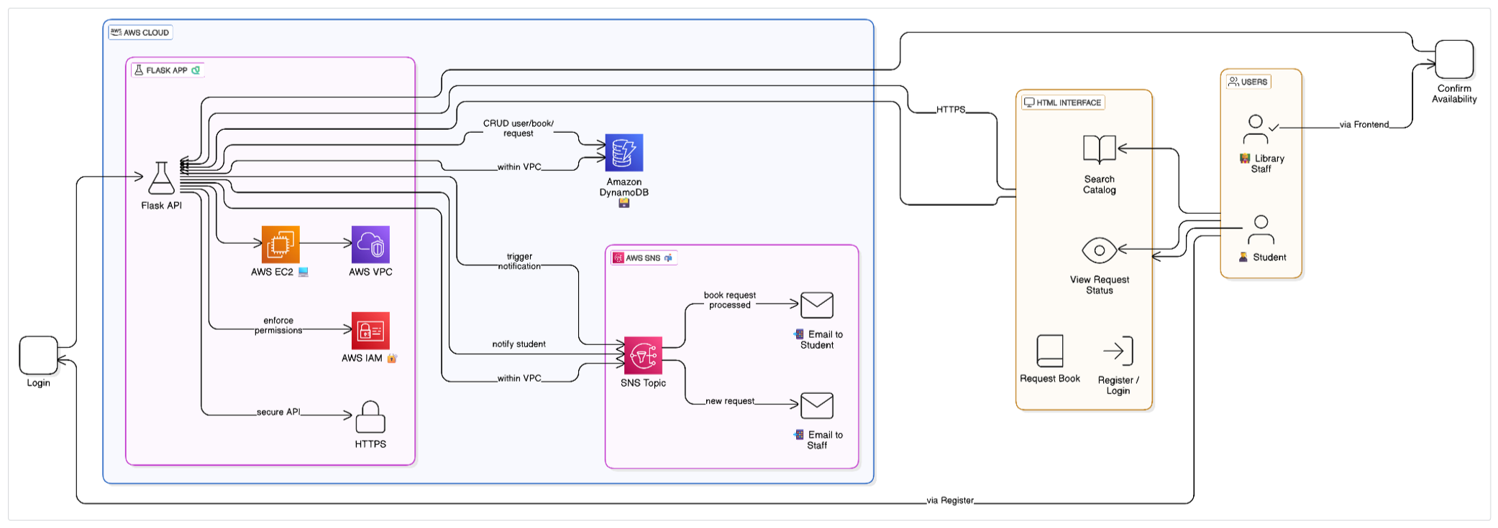

**Entity Relationship (ER)Diagram:(Example)**

 An ER (Entity-Relationship) diagram visually represents the logical structure of a database by defining entities, their attributes, and the relationships between them. It helps organize data efficiently by illustrating how different components of the system interact and relate. This structured approach supports effective database normalization, data integrity, and simplified query design.

(An **Entity-Relationship (ER) Diagram** is a **conceptual data modeling tool** used to visually describe the structure and organization of data in a system. It defines key components such as **entities**, **attributes**, and **relationships**, which form the foundation of a well-designed database.)

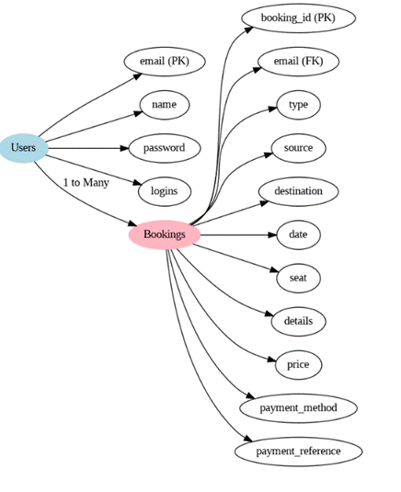

## **Pre-requisites**:

1. .**AWS Account Setup**:  [AWS Account Setup](https://youtu.be/CjKhQoYeR4Q?si=ui8Bvk_M4FfVM-Dh)
2. **Understanding IAM**:  [IAM Overview](https://youtu.be/gsgdAyGhV0o?si=3qg-bULgkD4LXNvR)
3. **Amazon EC2 Basics**: [EC2 Tutorial](https://youtu.be/8TlukLu11Yo?si=MUj0nEAOESRhHUIz)
4. **DynamoDB Basics**:  [DynamoDB Introduction](https://docs.aws.amazon.com/dynamodb)
5. **SNS Overview**:  [SNS Documentation](https://docs.aws.amazon.com/sns)
6. **Git Version Control**: [Git Documentation](https://git-scm.com/doc)

## **Project Milestones**

### ****Milestone 1: Backend Development and Application Setup****

* Develop the backend using Flask (Python microframework).
* Integrate AWS services such as DynamoDB and SNS using the boto3 library.

### ****Milestone 2: AWS Account Setup and Login****

* Set up an AWS account (if not already done).
* Log in to the AWS Management Console to access and configure services.

### ****Milestone 3: DynamoDB Database Creation and Setup****

* Create a DynamoDB table for storing user data and book requests.
* Define and configure attributes such as UserID, BookID, RequestStatus, etc.

### ****Milestone 4: SNS Notification Setup****

* Create SNS topics for book request notifications.
* Subscribe students and library staff to email notifications via AWS SNS.

### ****Milestone 5: IAM Role Setup****

* Create an IAM role for the application or EC2 instance.
* Attach required IAM policies to allow access to DynamoDB, SNS, and other AWS services securely.

### ****Milestone 6: EC2 Instance Setup****

* Launch an EC2 instance (e.g., Amazon Linux or Ubuntu).
* Configure security groups to allow HTTP (port 80) and SSH (port 22) access.

### ****Milestone 7: Deployment on EC2****

* Upload Flask project files to the EC2 instance.
* Install dependencies and run the Flask application on the instance.

### ****Milestone 8: Testing and Deployment****

* Perform functional testing:
  + User registration
  + Login authentication
  + Book requests
  + Email notifications
* Verify successful deployment and real-time behavior of the system.

### ****Milestone 1: Backend Development and Application Setup****

* 1. Develop the backend using Flask (Python microframework).

○ File Explorer Structure

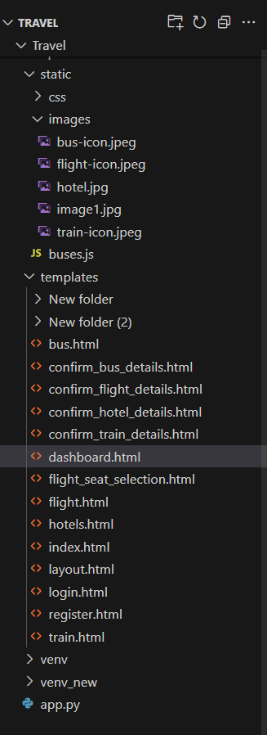

The displayed folder structure represents a well-organized Flask-based web application named **TravelGo**, which facilitates real-time travel booking. At the core, the app.py file serves as the backend controller, handling routes, database operations, and AWS integrations using services like DynamoDB and SNS. The static folder contains subfolders for CSS and images, where travel-related icons (bus-icon.jpeg, flight-icon.jpeg, etc.) are stored for use in the frontend UI. A JavaScript file, buses.js, likely manages dynamic behaviors or filtering for bus-related content.

**IMPORT LIBRARIES FOR BACKEND:**

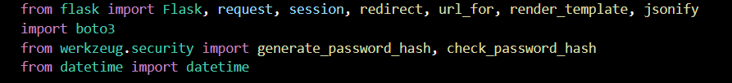

**Description:** Import essential Flask modules for web handling, Boto3 for AWS integration, Werkzeug for password hashing, and datetime for timestamp management.

**Flask App Initialization:**

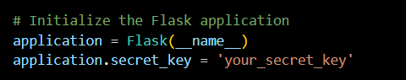

**Description:** Initialize the Flask application and set a secret key to securely manage user sessions and form data.

**Database Configuration:**

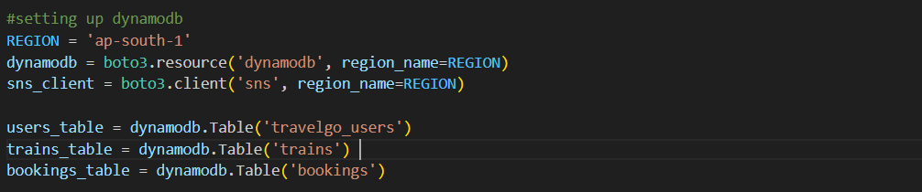

**Description:** Connect to DynamoDB using Boto3 and define references to travelgo_users,trains,and bookings to booking purpose.

LOCAL DEPLOYMENT:

**Routes for Core Functionalities:**

**Index and registration routes:**

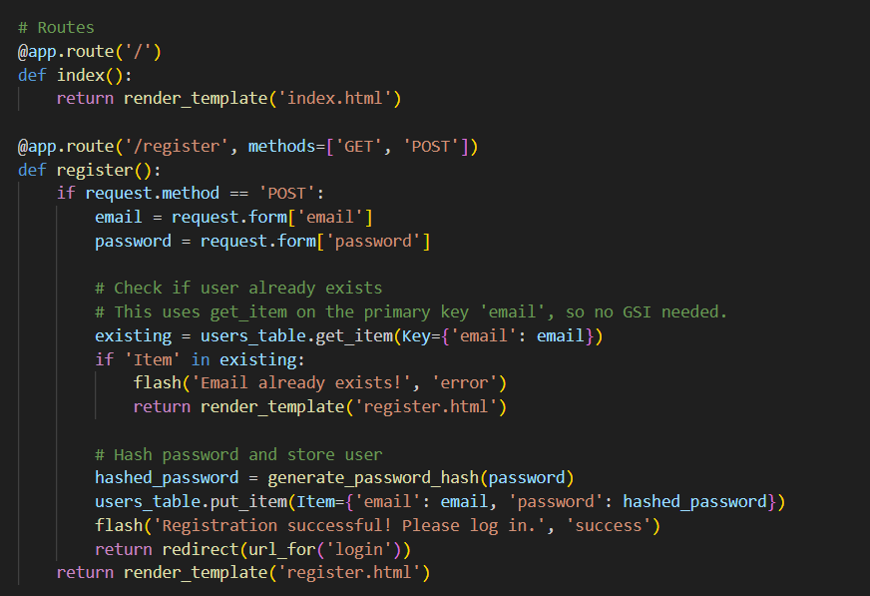

**Description:** Create the home and registration routes, where the registration route securely hashes user passwords and stores user data in DynamoDB upon form submission.

**Login routes:**

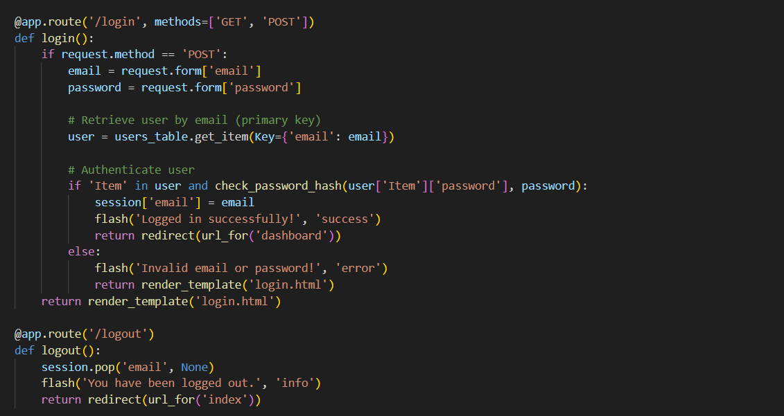

**Description:** Implement the user login route to validate credentials using DynamoDB and securely manage session data while updating the user's login count.

**User dashboard and booking price details:**

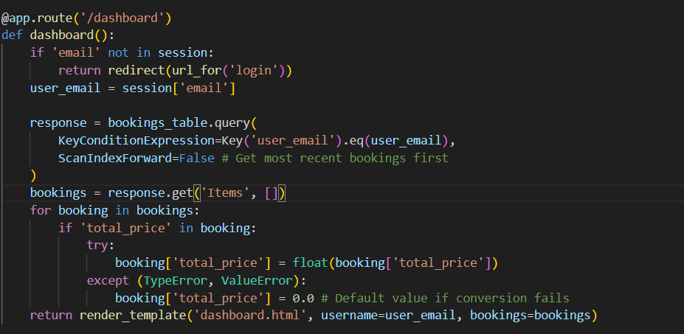

**Description:**Secure the user dashboard and implement a route to add items to the wishlist, storing them in DynamoDB with item details and a timestamp.

**Train Booking Details and Train Confrim Details:**

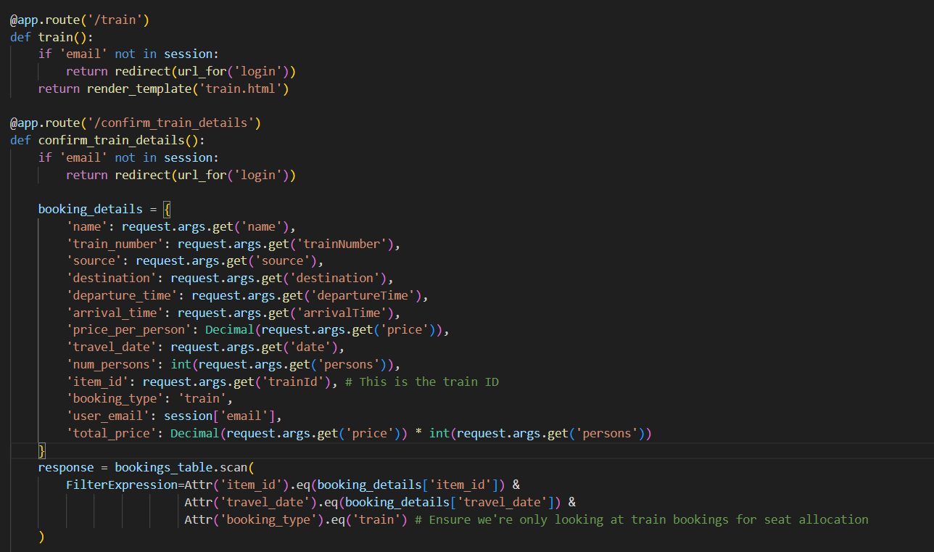

**Description:**  Build routes to display, fetch, and delete wishlist items for logged-in users by querying and modifying entries in DynamoDB using the user's email. The **Train Booking** section of TravelGo offers users a seamless experience to search and reserve train tickets between their preferred source and destination stations. Users can view available trains, departure and arrival times, ticket prices, and travel class.

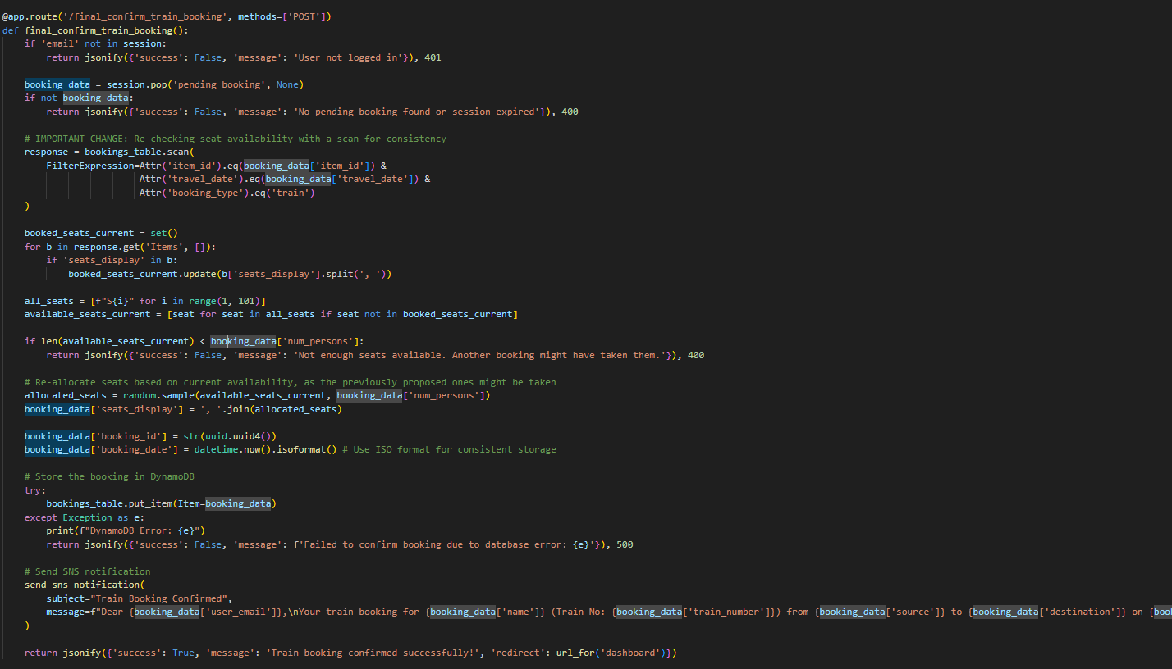

Once a suitable train is selected, the **Train Confirm Details** page provides a clear summary of the booking, including passenger details, selected train information, journey date, and total fare. This confirmation step ensures that users can verify all travel details before proceeding with the final booking, enhancing both accuracy and user satisfaction.

**Bus and Bus confirm details:**

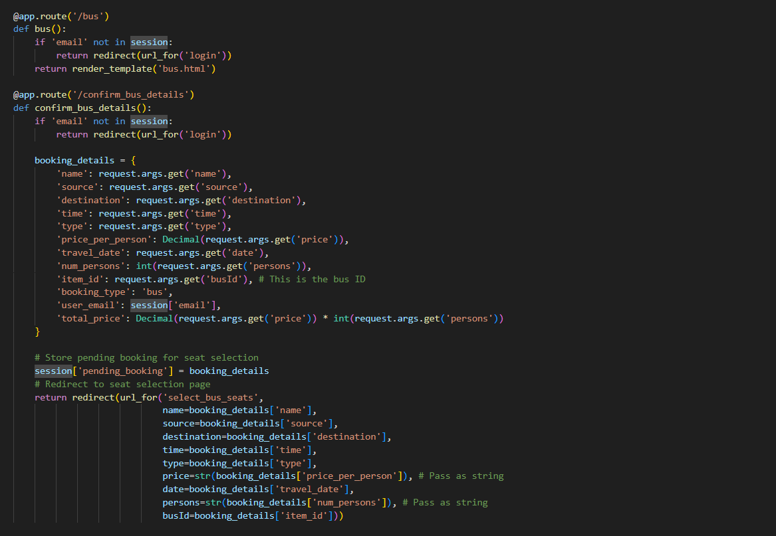

**Description:** Create a route for the **Bus Booking** section in TravelGo allows users to conveniently browse and book bus tickets for various routes. Users can search buses based on source, destination, and date of journey, and view essential details such as bus type, departure and arrival times, seat availability, and fare. After choosing a preferred bus, the **Bus Confirm Details** page displays a complete summary of the selected bus, including boarding and dropping points, seat number, and passenger details. This confirmation step helps users double-check all information before finalizing the booking, ensuring a smooth and reliable travel experience.

**Selection Seats for Bus:**

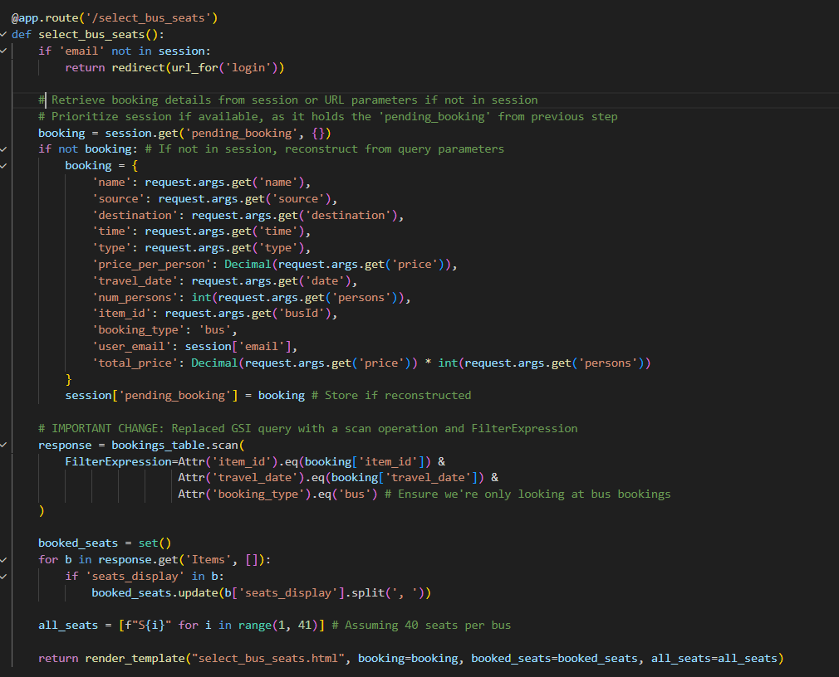

**Description:** The **Bus Seat Selection** feature in TravelGo provides users with an interactive layout of available seats in the chosen bus. Users can visually pick their preferred seats based on availability, ensuring a more personalized travel experience. Each seat is clearly marked as available, booked, or selected, allowing users to make informed choices. Once a seat is selected, it gets highlighted, and the fare is updated accordingly. This intuitive seat selection system enhances user convenience, transparency, and satisfaction by giving control over where they wish to sit during their journey.

**Flight and confirm flight booking:**

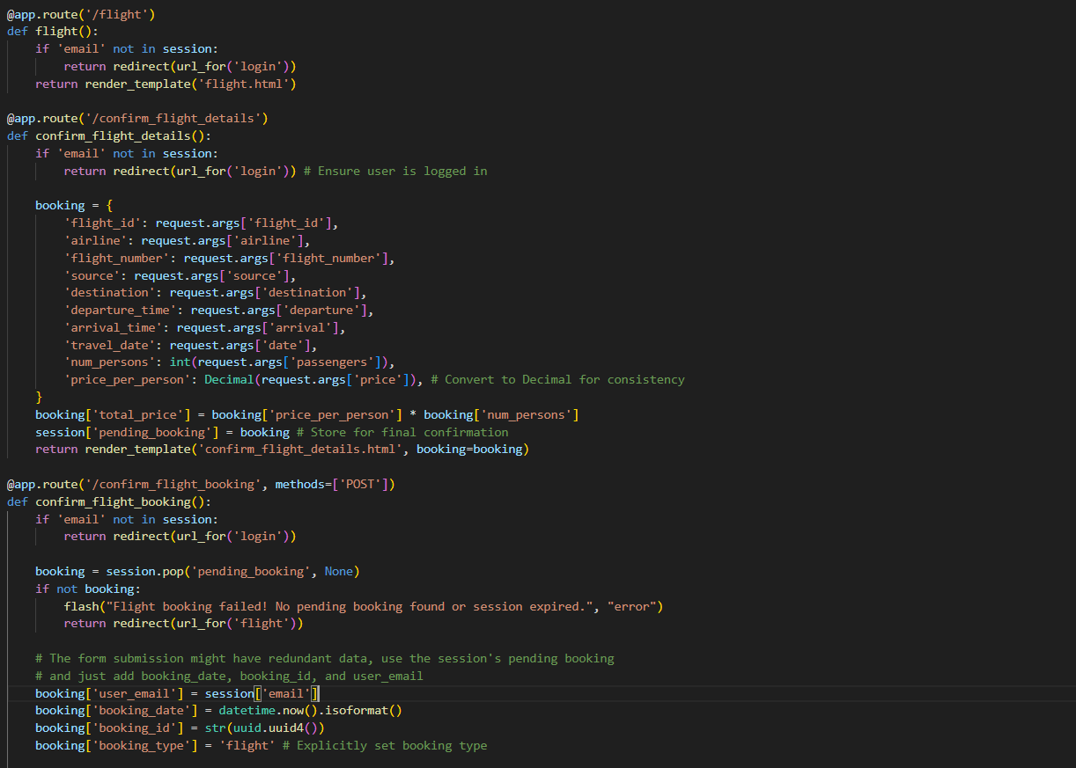

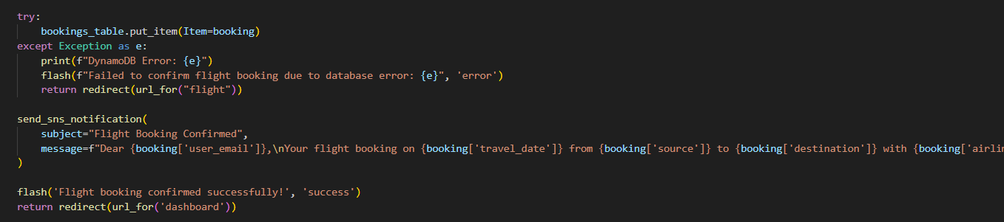

**Description:** The **Flight Booking** section of TravelGo allows users to search for flights between selected cities based on departure and return dates. Users can view detailed flight options, including airline name, departure/arrival time, duration, and ticket price. After selecting a suitable flight, the **Confirm Flight Details** page presents a complete summary of the booking, showing flight number, passenger details, travel class, and fare breakdown. This confirmation step ensures that all flight details are accurate before final submission, providing users with a clear and trustworthy booking process.

**Hotel and confirm Hotel details:**

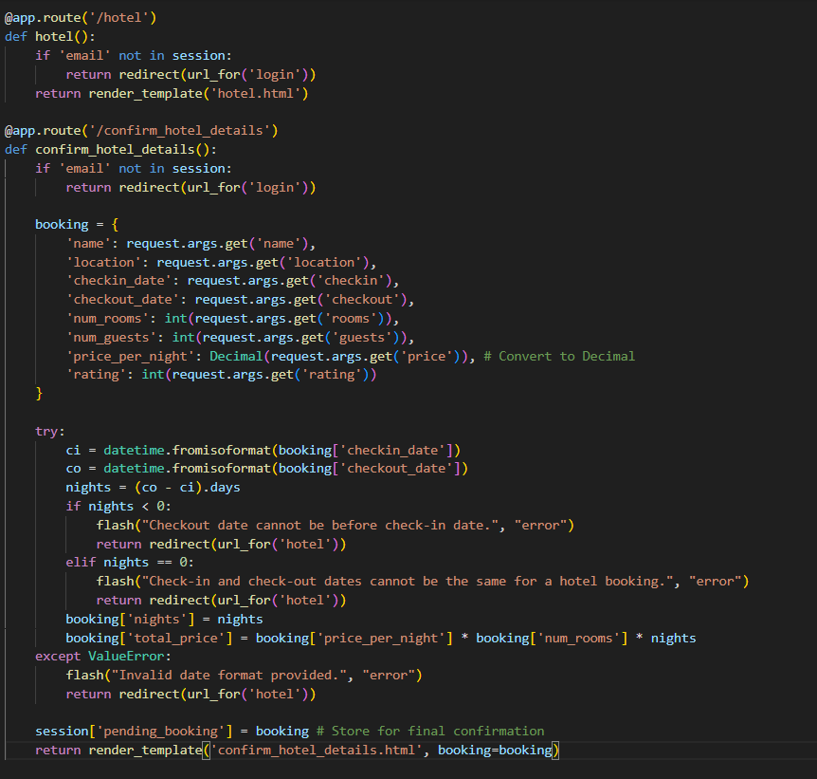

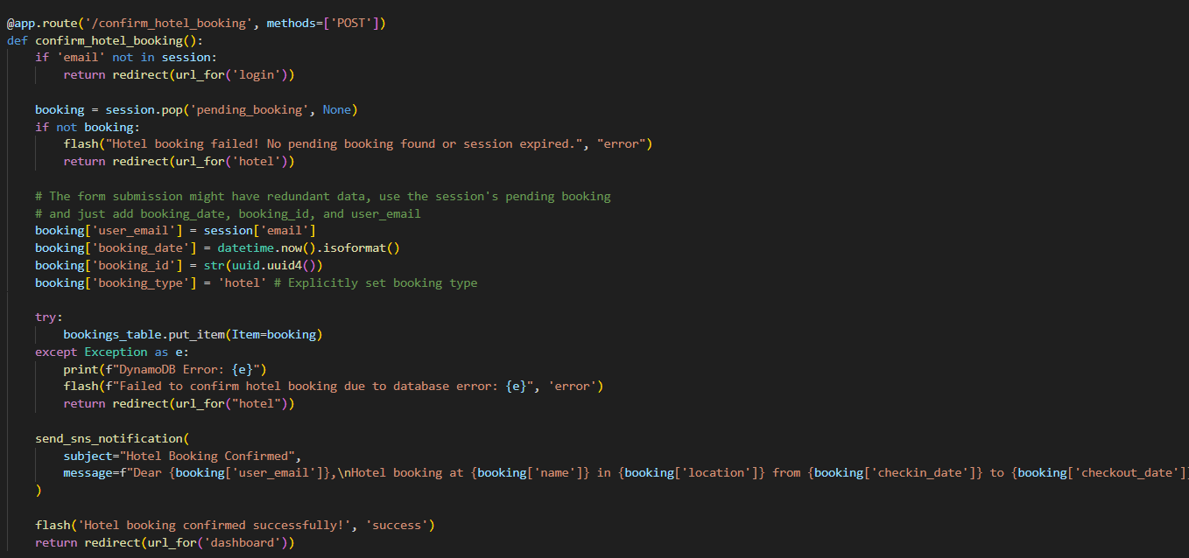

**Description:** The **Hotel Booking** section in TravelGo helps users find and reserve accommodations based on their destination, travel dates, and preferences. Users can explore a wide range of hotels with details like hotel name, location, room type, price per night, amenities, and user ratings. Once a hotel is selected, the **Confirm Hotel Details** page displays a detailed summary including guest information, number of rooms, check-in and check-out dates, and total cost. This confirmation step allows users to review all booking details before finalizing, ensuring accuracy and a smooth hotel stay experience.

**Flight booking cancellation:**

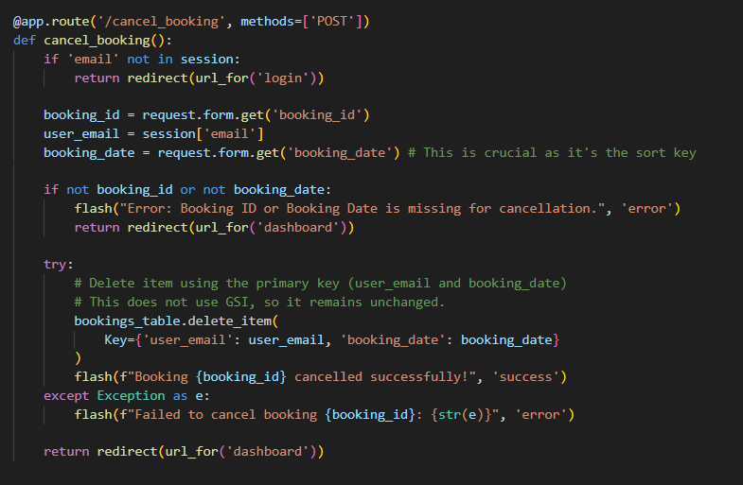

**Description:** The **Flight Booking Cancellation** feature in TravelGo allows users to easily cancel their previously booked flights with just a few clicks. Users can access their booking details, review flight information, and choose the option to cancel if plans change. Once the cancellation is confirmed, the system updates the booking status and releases the reserved seats. Users may also receive notifications or refund information based on the airline's cancellation policy. This feature ensures flexibility and user control, making travel planning more adaptable and stress-free.

**Initiating Flask app**

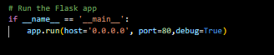

**Description:** Start the Flask application on host 0.0.0.0 and port 80 in debug mode to enable live reloads and detailed error logs during development.

### ****Milestone 2: AWS Account Setup and Login****

### 2.1: Set up an AWS account

### Sign up for an AWS account and configure billing settings.

### 

Go to the AWS website (<https://aws.amazon.com/>).

* Click on the "Create an AWS Account" button.
* Follow the prompts to enter your email address and choose a password.
* Provide the required account information, including your name, address, and phone number.
* Enter your payment information. (Note: While AWS offers a free tier, a credit card or debit card is required for verification.)
* Complete the identity verification process.
* Choose a support plan (the basic plan is free and sufficient for starting).
* Once verified, you can sign in to your new AWS accounts.

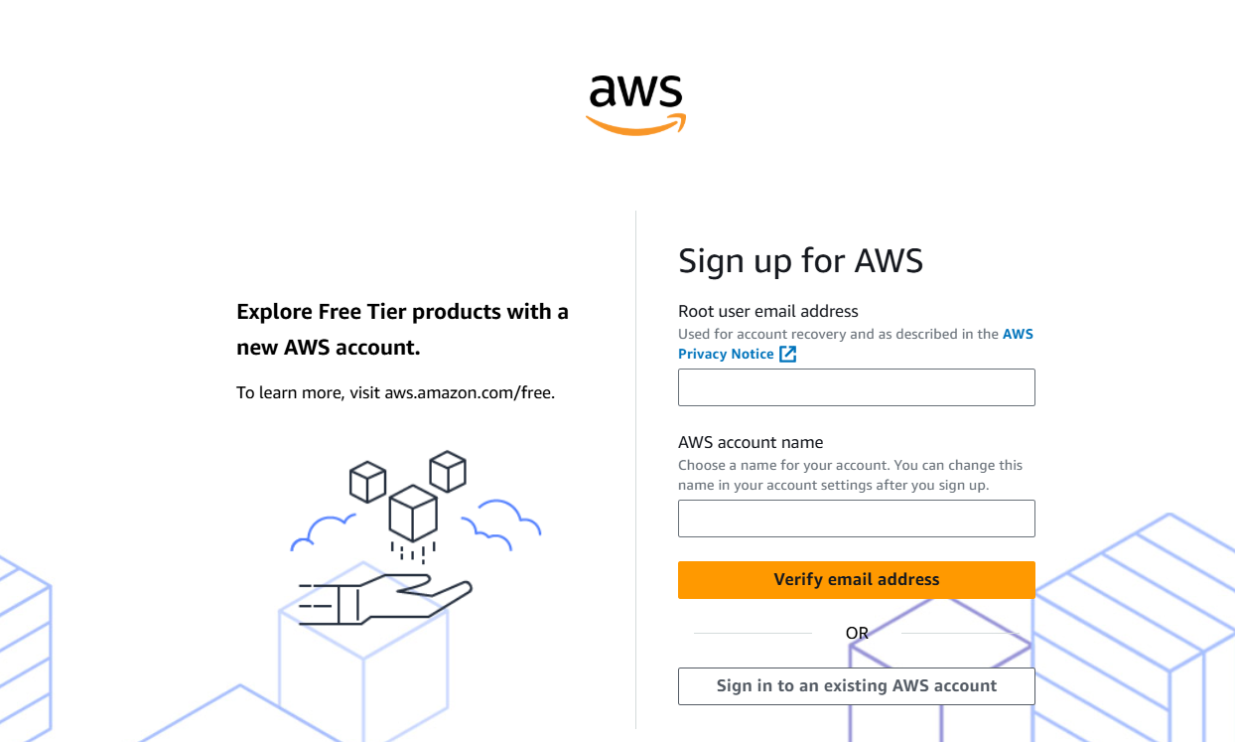

* Log in to the AWS Management Console

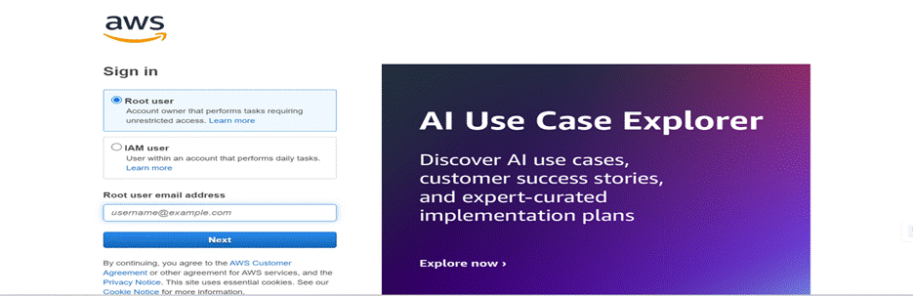

After setting up your account, log in to the[AWS Management Console](https://aws.amazon.com/console/).

### Milestone 3 : DynamoDB Database Creation and Setup

### Database Creation and Setup involves initializing a cloud-based NoSQL database to store and manage application data efficiently. This step includes defining tables, setting primary keys, and configuring read/write capacities. It ensures scalable, high-performance data storage for seamless backend operations.

### 3.1: Navigate to DynamoDB:

### In the AWS Console, navigate to DynamoDB and click on create tables.

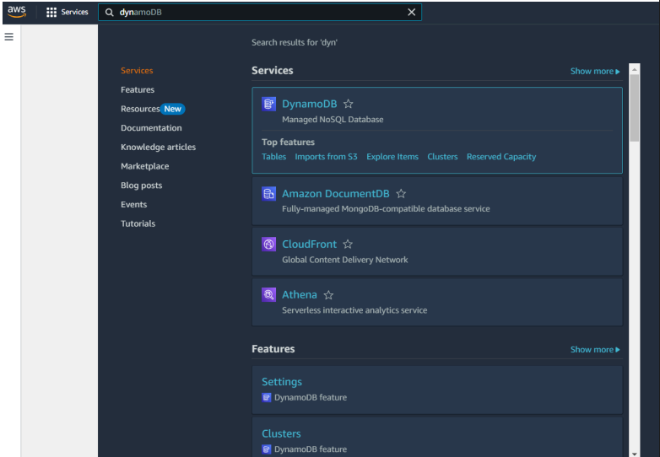

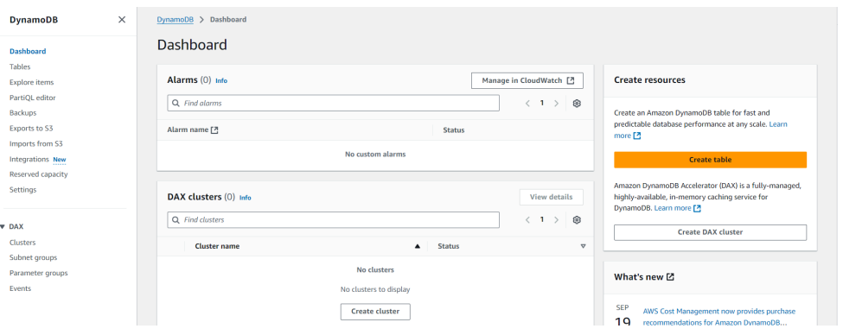

**Activity 3.2:**

* Create a DynamoDB table for storing registration details and book requests.
* Create travel - Users table with partition key “Email” with type String and click on create tables.

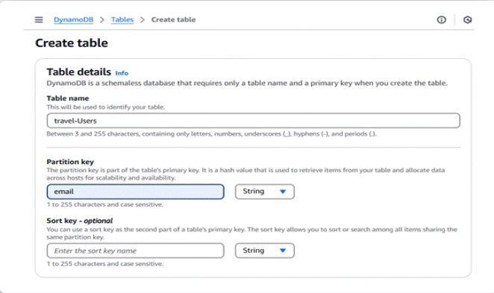

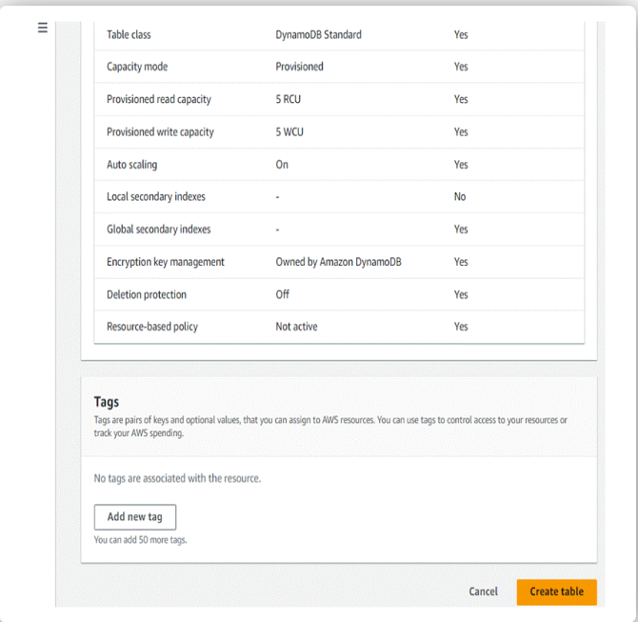

* Likewise, Create bookings table with partition key “Email” with type String and click on create tables.
* Create trains table with partition key “train-number” with type String and click on create tables.

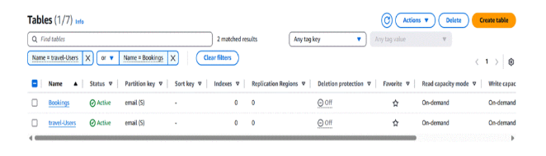

Here , trains table are also visible after creation of trains table.

Tables are created. Next SNS.

### Milestone 4 : SNS Notification Setup

Amazon SNS is a fully managed messaging service that enables real-time notifications through channels like SMS, email, or app endpoints. You create topics, configure subscriptions, and integrate SNS into your app to send notifications based on specific events.

**Activity 4.1:**

* + Create SNS topics for sending email notifications to users and library staff.
  + In the AWS Console, search for SNS and navigate to the SNS Dashboard.

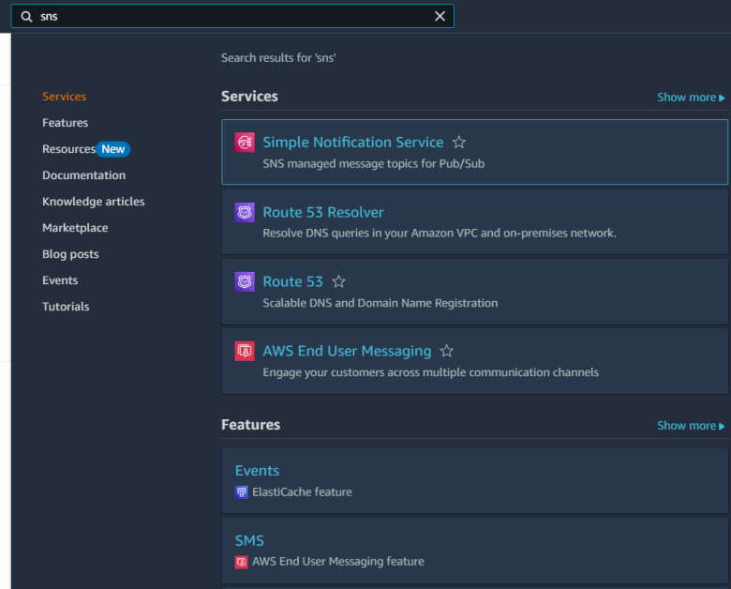

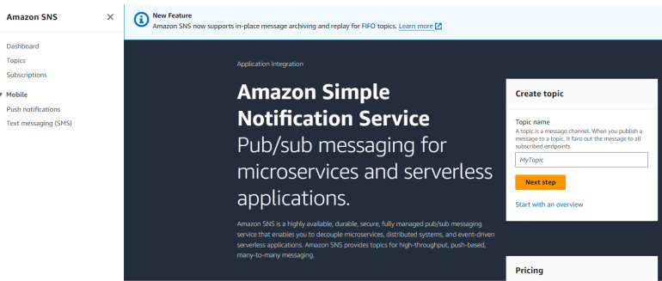

* Click on start with an overview or at the left topics.

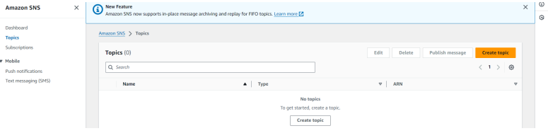

* Click on Create Topic and choose a name for the topic.

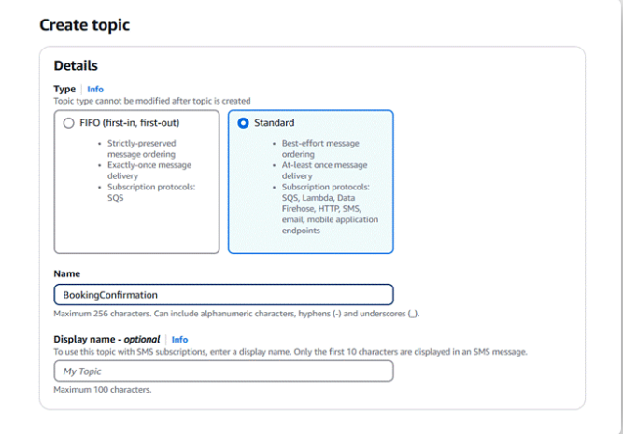

* Choose Standard type for general notification use cases and Click on Create Topic.

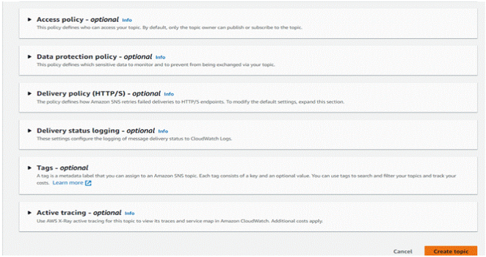

* Configure the SNS topic and note down the Topic ARN.

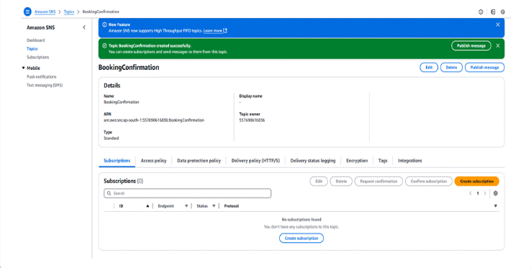

**Activity 4.2:**

Subscribe users and staff to relevant SNS topics to receive real-time notifications when a book request is made.

* Subscribe users (or admin staff) to this topic via Email. When a book request is made, notifications will be sent to the subscribed emails.

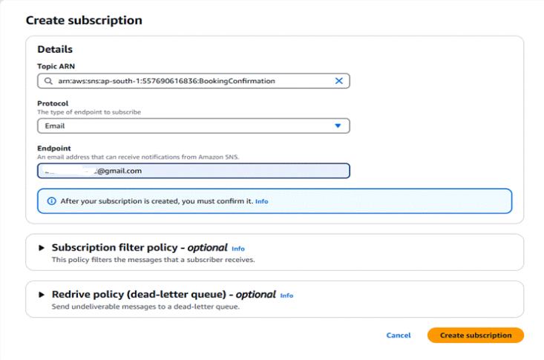

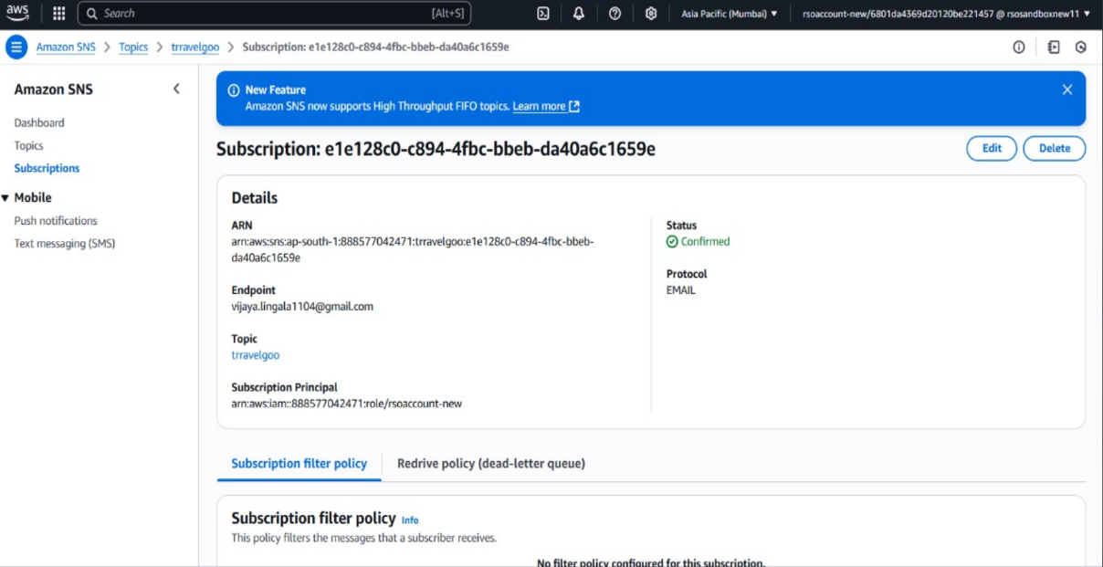

* After subscription request for the mail confirmation.

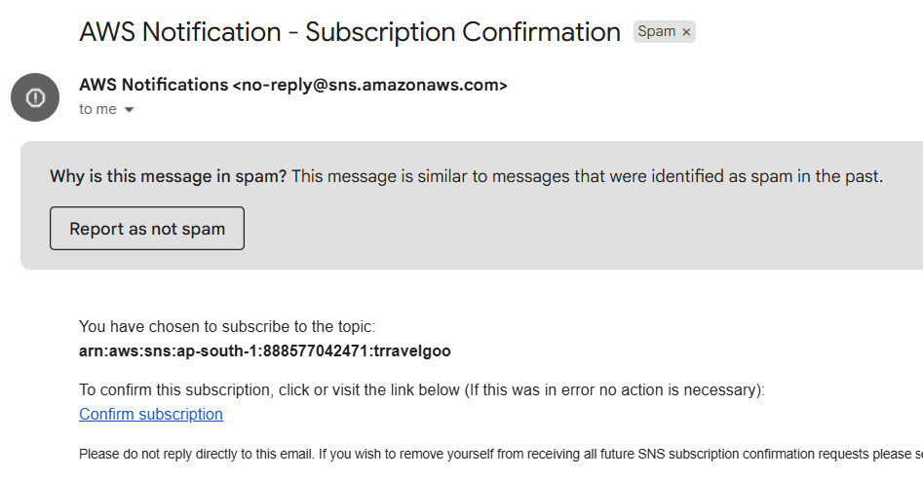

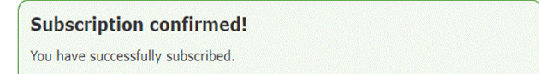

* Successfully done with the SNS mail subscription and setup, now store the ARN link.

### Milestone 5 : IAM Role Setup

IAM (Identity and Access Management) role setup involves creating roles that define specific permissions for AWS services. To set it up, you create a role with the required policies, assign it to users or services, and ensure the role has appropriate access to resources like EC2, S3, or RDS. This allows controlled access and ensures security best practices in managing AWS resources.

**Activity 5.1:**

* Create an IAM role for the application or EC2 instance.

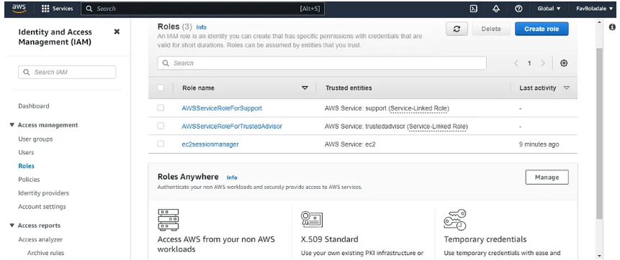

* After clicking IAM Create Role

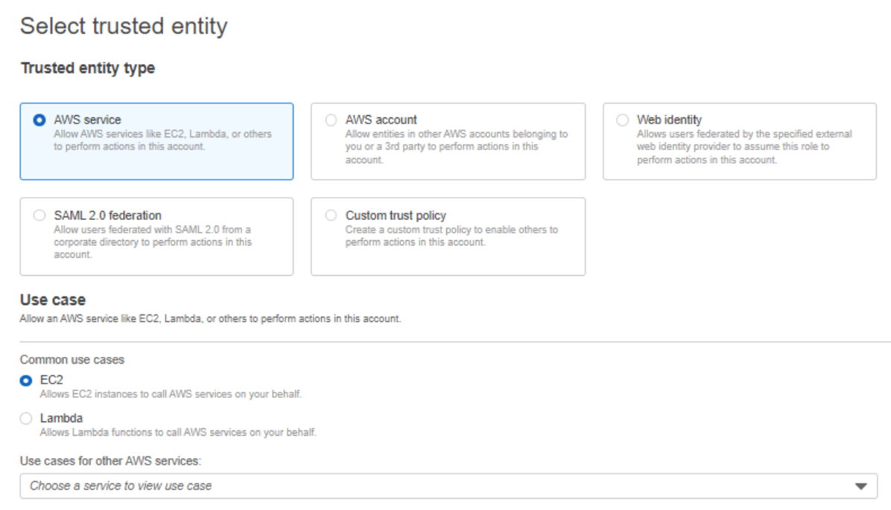

**Activity 5.2:**

Attach Policies. Attach the following policies to the role:

● AmazonDynamoDBFullAccess: Allows EC2 to perform read/write operations on DynamoDB.

● AmazonSNSFullAccess: Grants EC2 the ability to send notifications via SNS

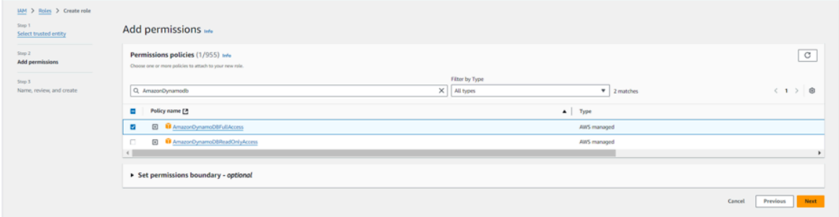

* Same process for EC2 and SNS.

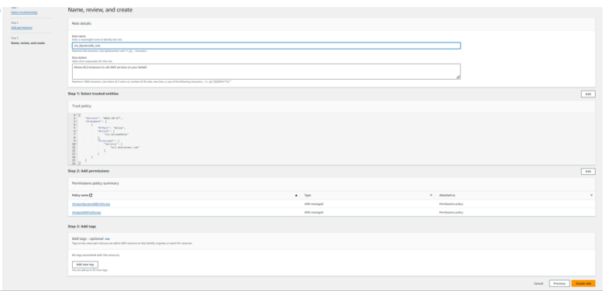

* After selecting the policies role name should be role name should be created.
* Next, click on create role.

**Milestone 6 : EC2 Instance Setup**

* Note: Load your Flask app and Html files into GitHub repository.

      To set up a public EC2 instance, choose an appropriate Amazon Machine Image (AMI) and instance type. Ensure the security group  allows inbound traffic on necessary ports (e.g., HTTP/HTTPS for web applications). After launching the instance, associate it with an elastic  IP for consistent public access, and configure your application or services to be publicly accessible.

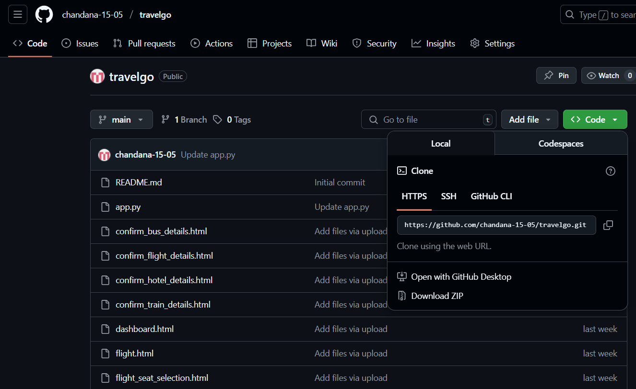

* Launch EC2 Instance ○ In the AWS Console, navigate to EC2 and launch a new instance.

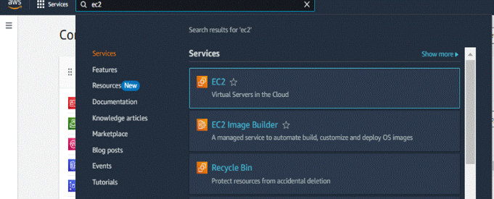

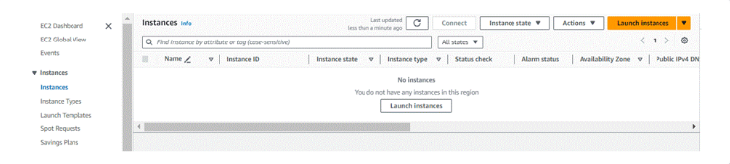

* Click on Launch instance to launch EC2 instance

* Give a name

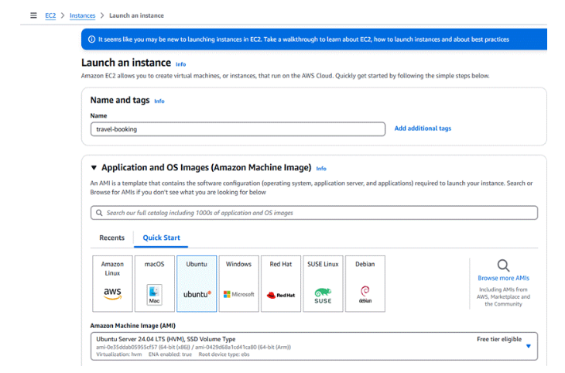

* Create key pair access. And the key pair is automatically downloaded.

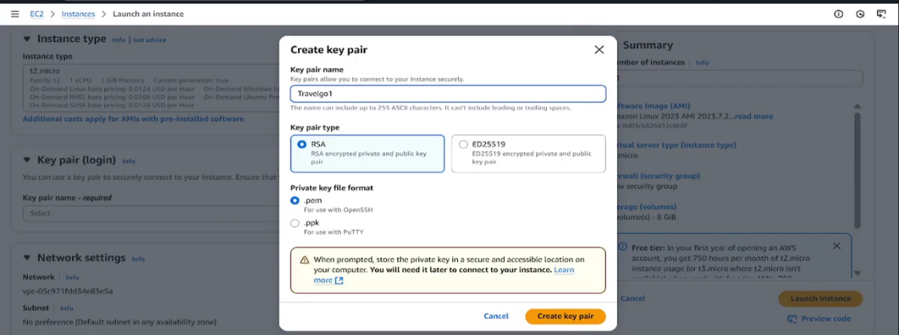

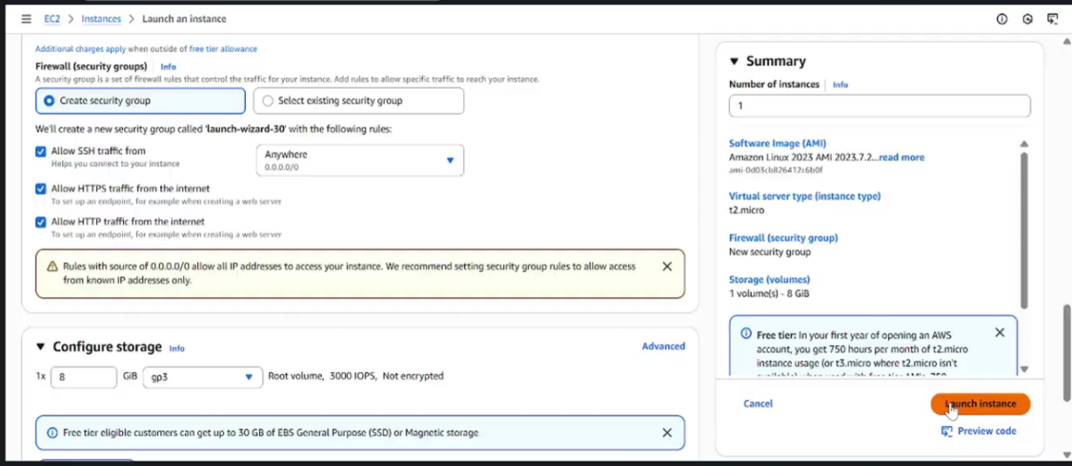

* By selecting, Allow HTTPS traffic from the internet .
* Allow HTTPS traffic from the internet .
* Select launch instance.

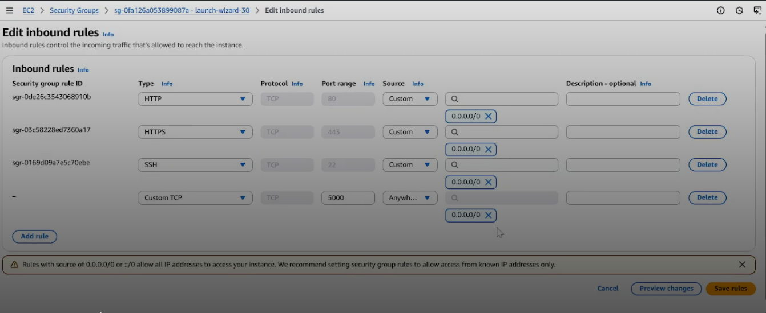

* In the above picture, after completed launch instance. Select the EC2 instance that is create on EC2 . and at the down select security.
* In security , after clicking security groups , select edit inbound rules, then the click on add rule and give custom TCP, 5000, anywhere IPV4.

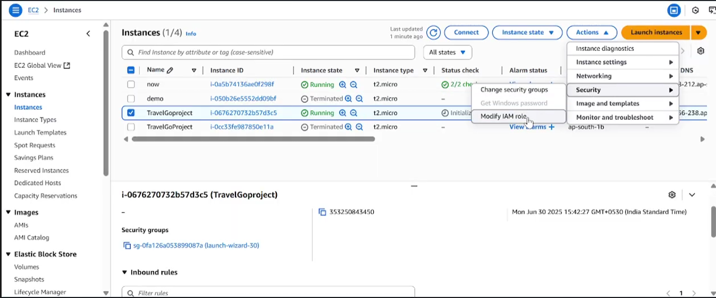

* To update IAM role , select Actions , in that select security and then modify IAM role. Next we go to next step as shown in below picture.

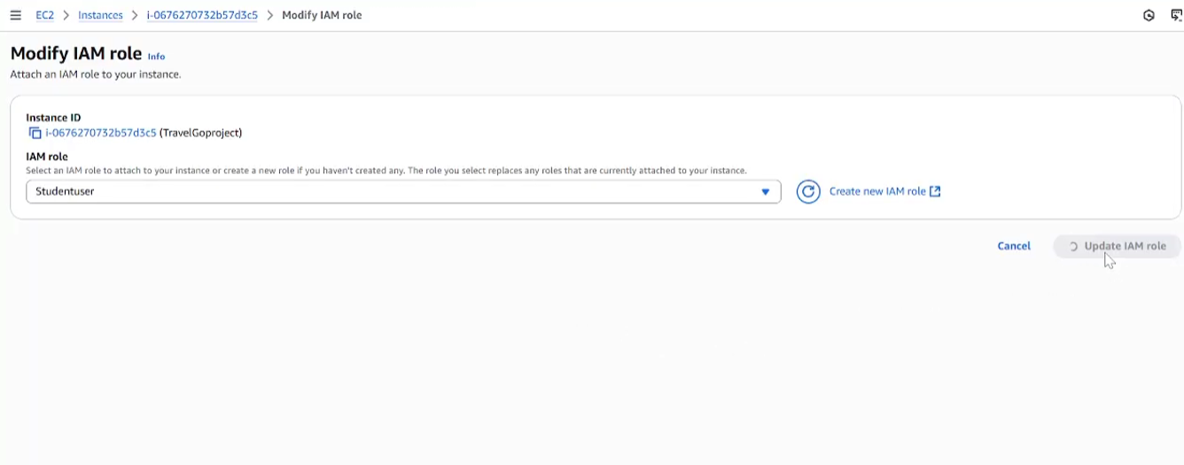

* Here , The IAM role will be updated.
* Next , as shown in below picture select connect.

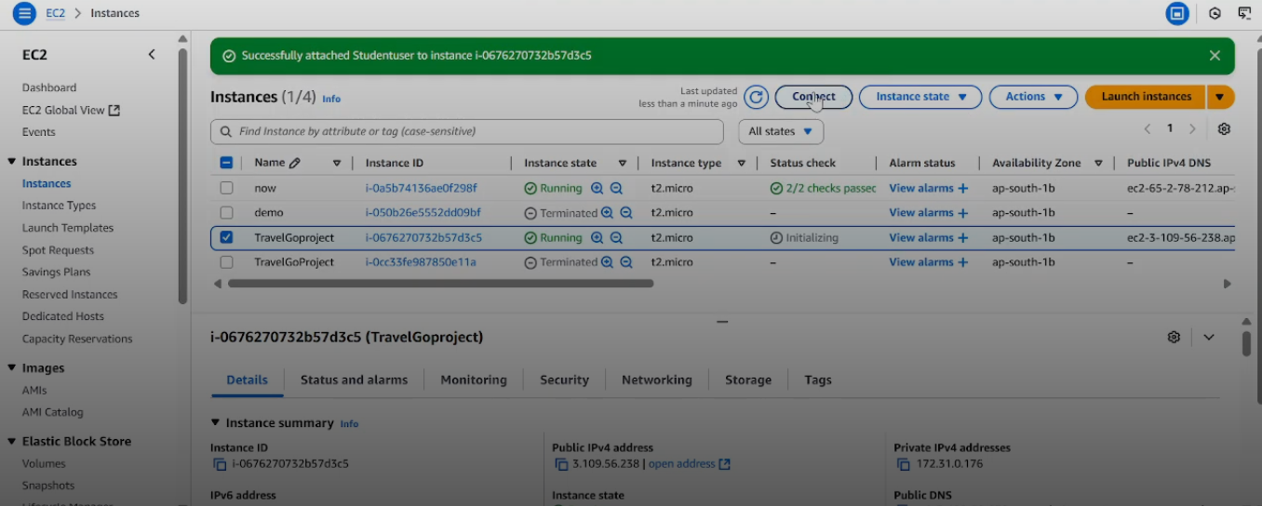

* Select SSH client, and copy the fourth points that is important in upcoming process. EC2 process is completed.

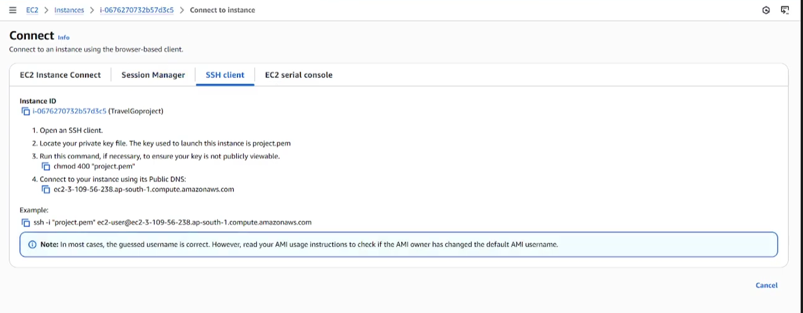

**Milestone 7: Deployment using EC2**

Deployment on an EC2 instance involves launching a server, configuring security groups for public access, and uploading your application files. After setting up necessary dependencies and environment variables, start your application and ensure it's running on the correct port. Finally, bind your domain or use the public IP to make the application accessible online.

ACTIVITY 7.1:

* Upload Flask project files to the EC2 instance.

Install dependencies and run the Flask application on the instance.

**Install Software on the EC2 Instance**

Install Python3, Flask, and Git:

* **Verify Installations:**

                                           flask --version

                                           git –version

* **On Amazon Linux 2:**

                                           sudo yum update -y

                                           sudo yum install python3 git

                                           sudo pip3 install flask boto3

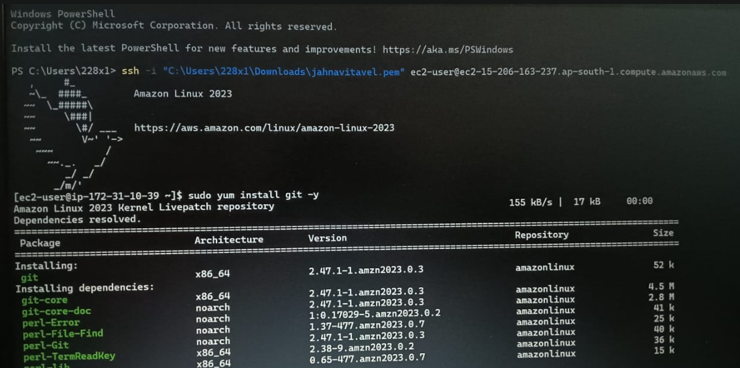

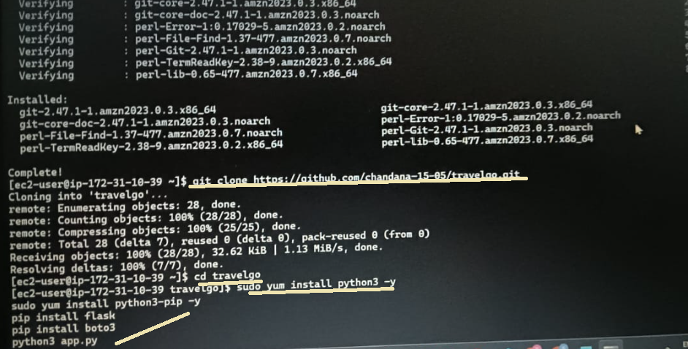

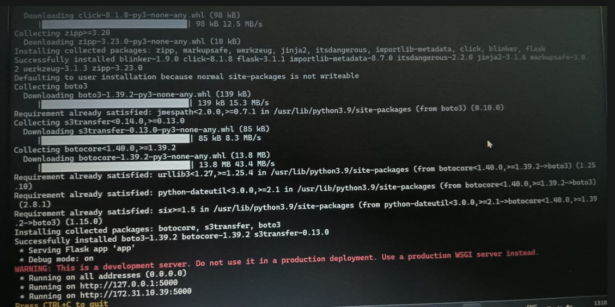

* Access the website through:

            PublicIPs: <http://172.31.10.39:5000/>

**Milestone 8 : Testing and Deployment**

Testing and deployment involve verifying that your application works as expected before making it publicly accessible. Start by testing locally or on a staging environment to catch bugs and ensure functionality. Once tested, deploy the application to an EC2 instance, configure necessary services, and perform a final round of live testing to confirm everything runs smoothly in the production environment.

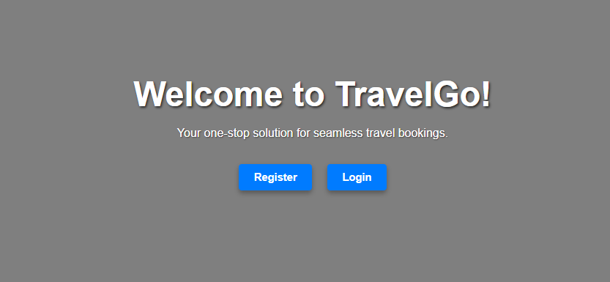

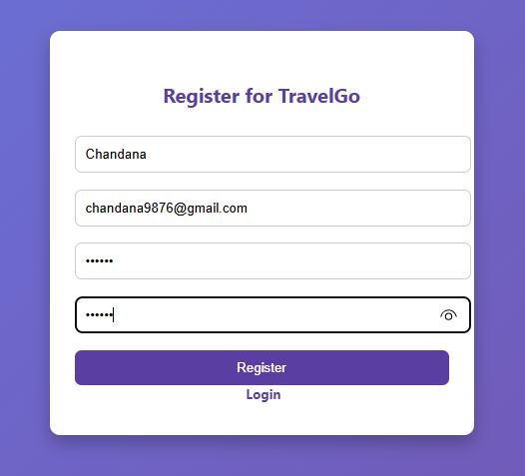

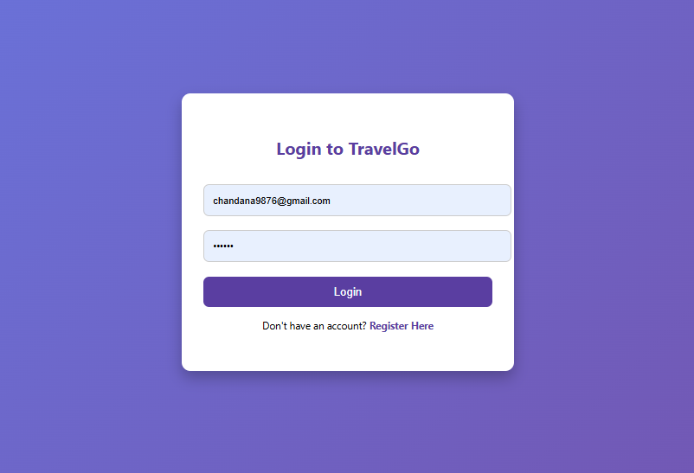

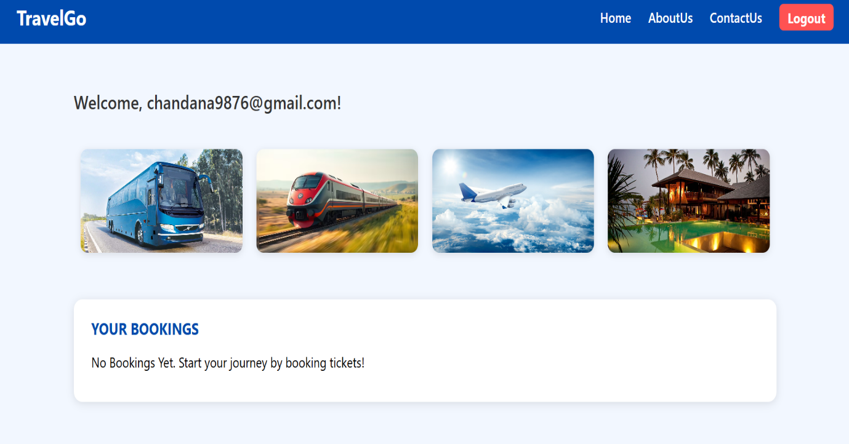

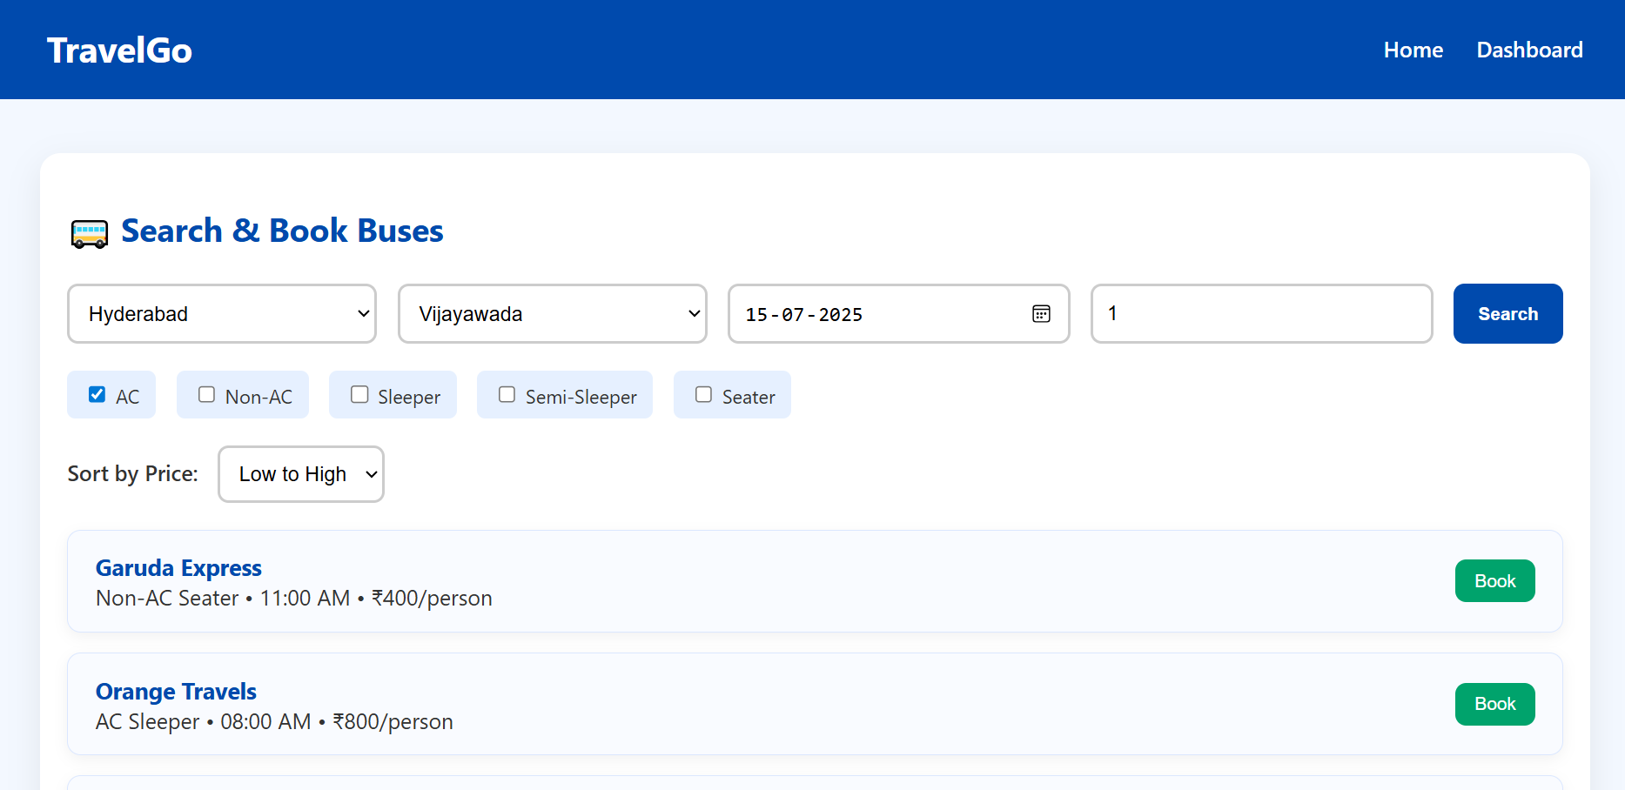

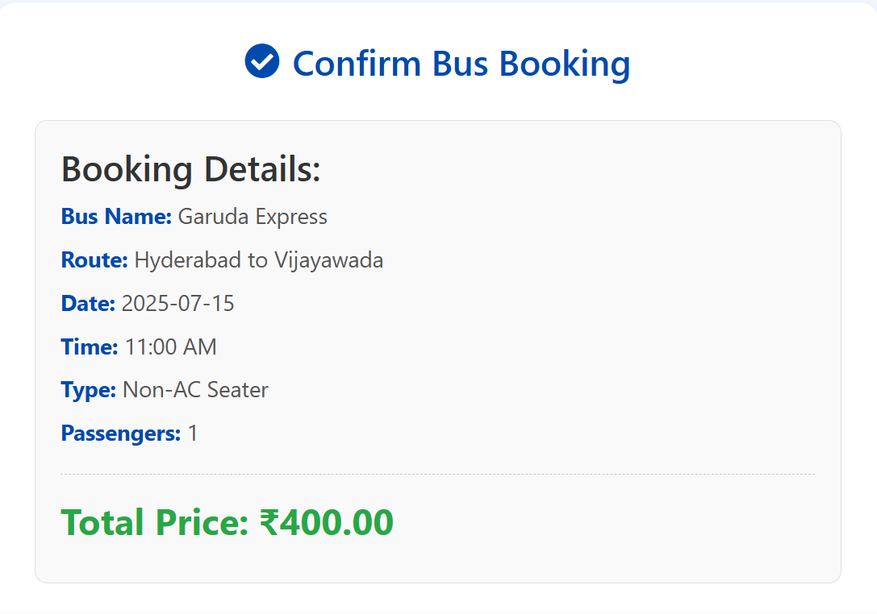

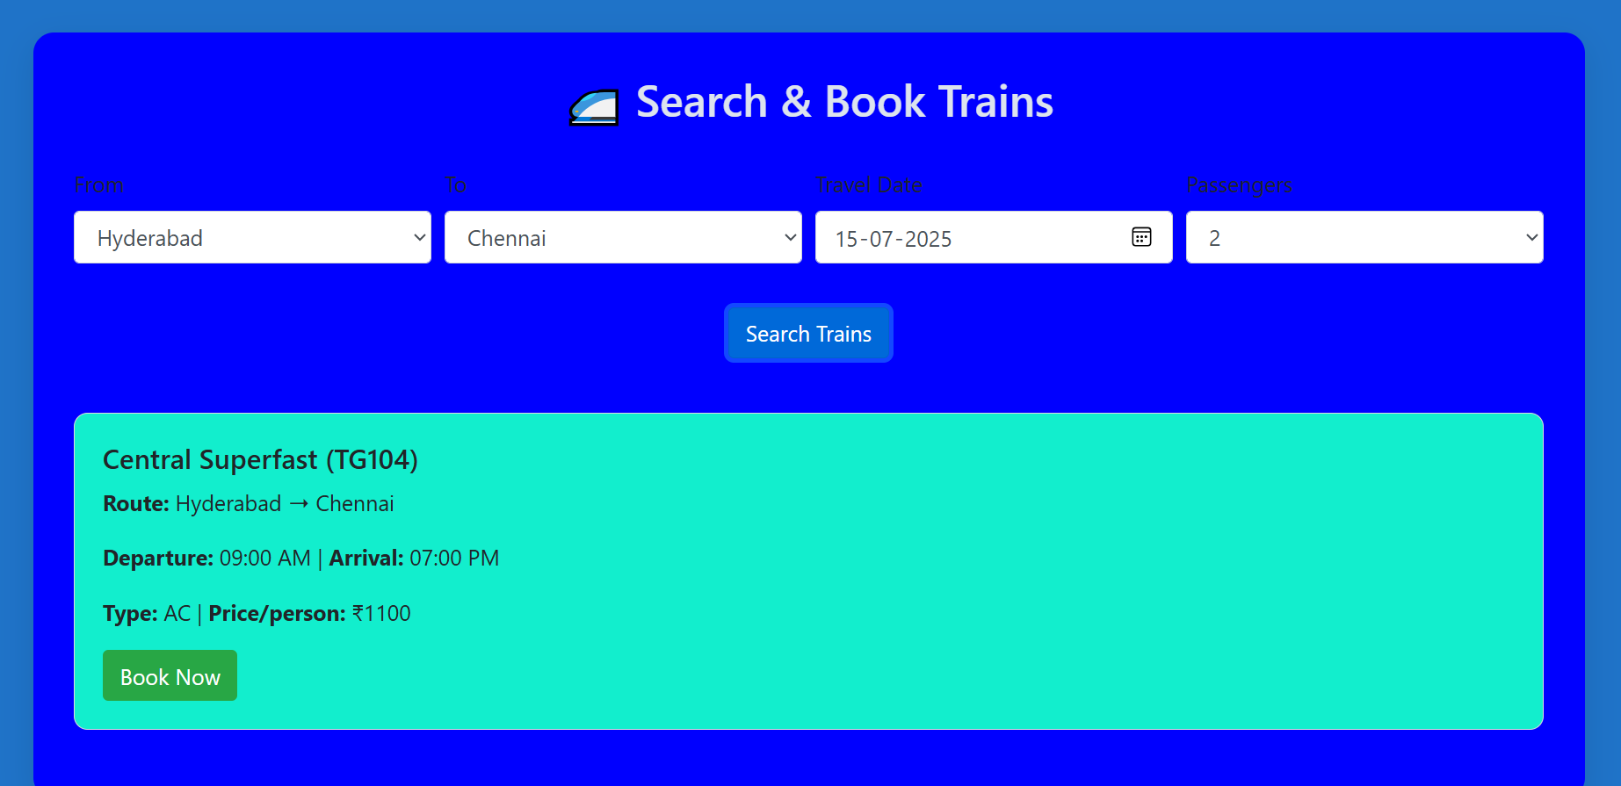

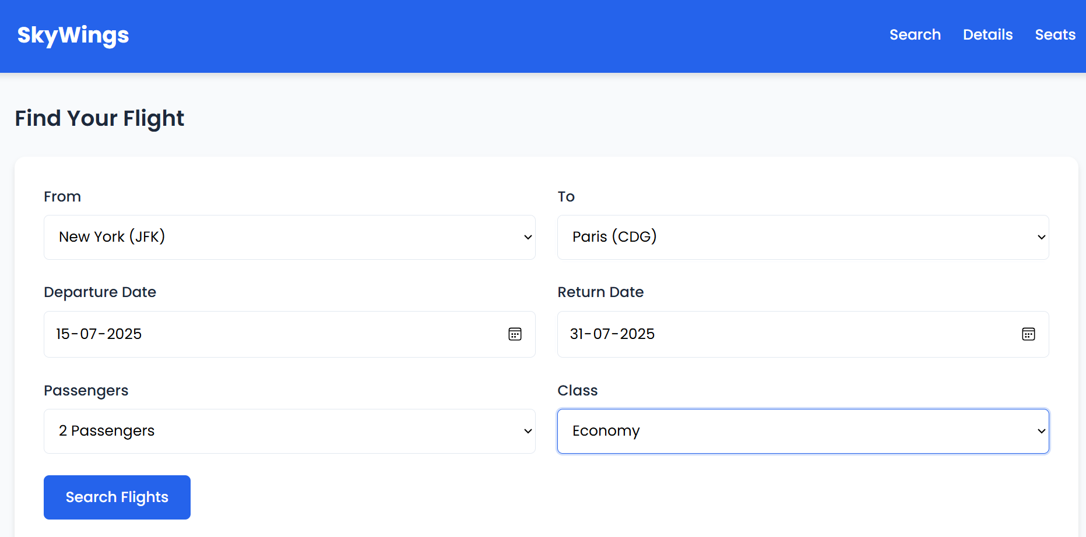

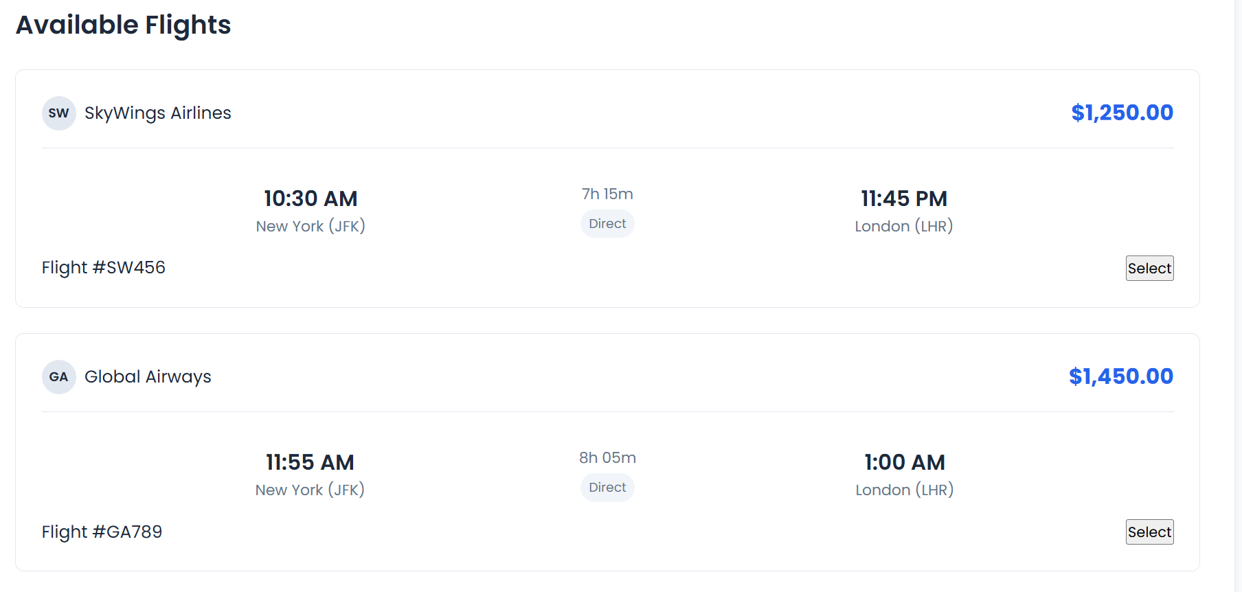

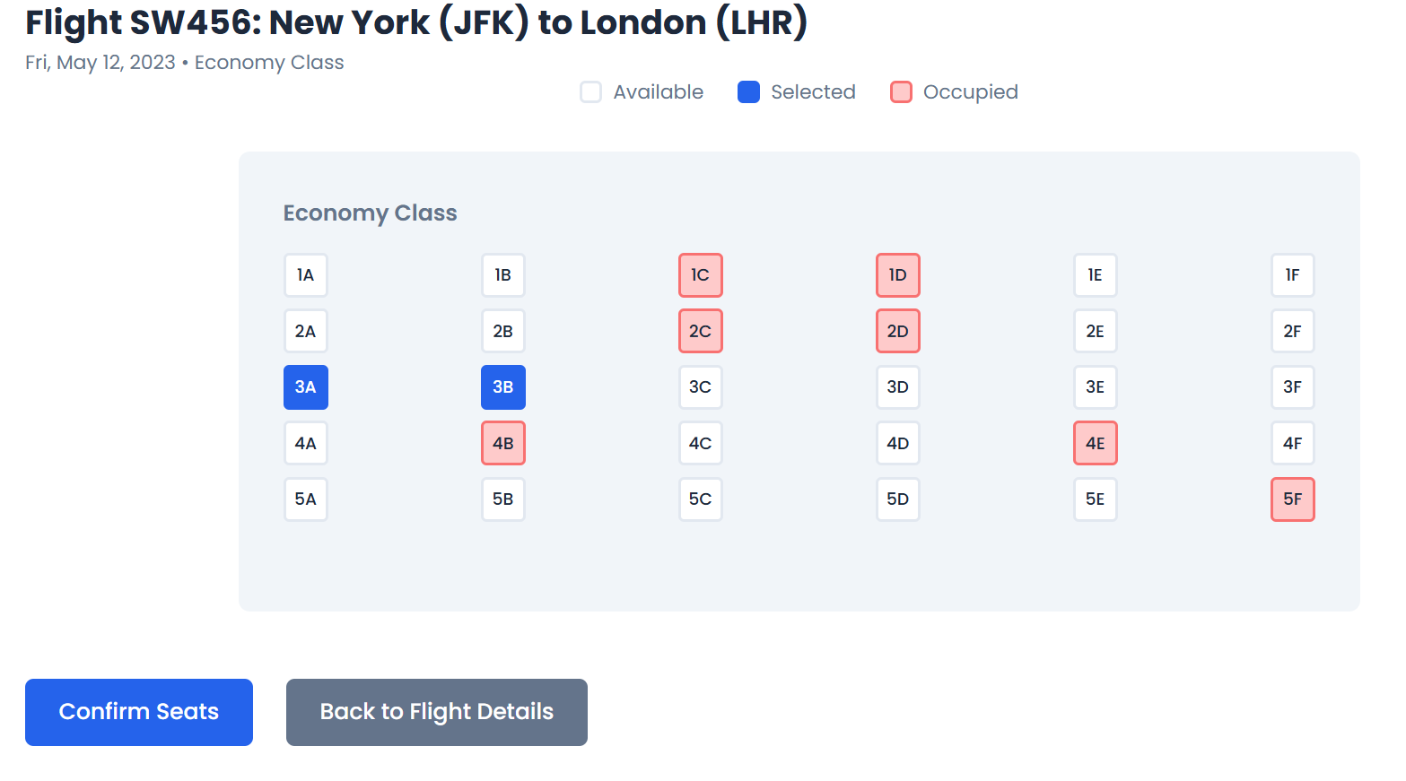

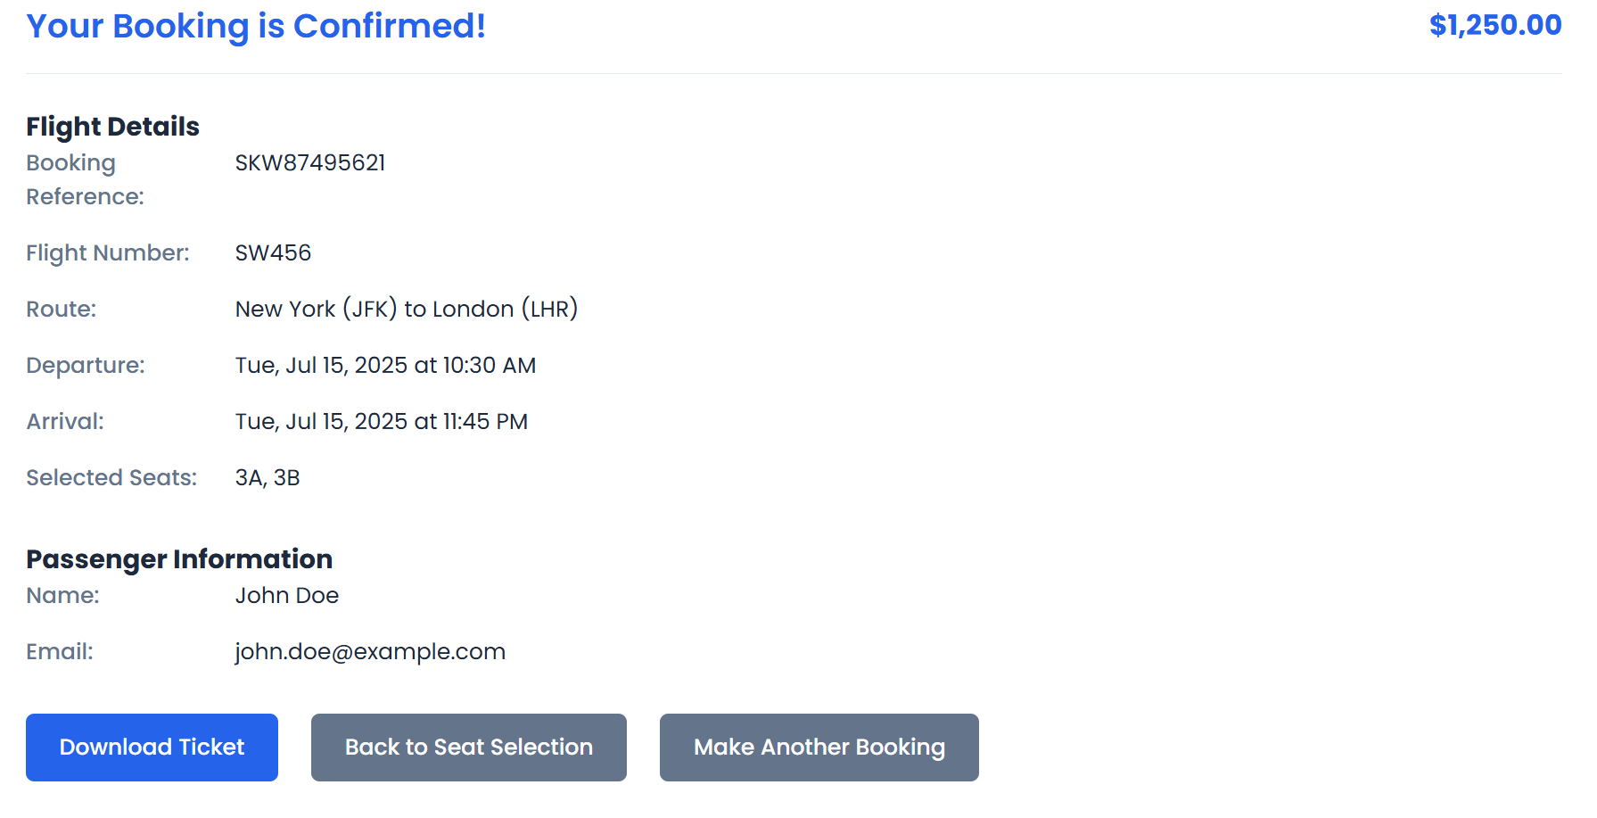

**Conclusion:**

The TravelGo project successfully demonstrates a robust, cloud-powered real-time travel booking platform that integrates modern web technologies with scalable AWS cloud services. By combining Flask for the backend and services like AWS DynamoDB, SNS, IAM and EC2, the platform enables users to search, filter, and book buses, trains, flights, and hotels with ease. The implementation of seat selection, booking confirmation, and cancellation features ensures a smooth end-to-end travel experience. Through this project, we gained hands-on experience in cloud deployment, full-stack development, and real-time data handling — making TravelGo a reliable, user-friendly, and scalable solution for digital travel booking.